**Modeling and simulation of a communication system for Distribution Power System -Case Study University Campus**

Jesus Ortiz Sandoval

Universidad Tecnica Federico Santa Maria

Valparaiso, Chile

1. **Introduction**

Smart grid is a project that involves many disciplines and that brings many economic, political and legislative challenges of the countries that have decided to implement this technology. One of the main implementations of this technology is related to the stabilization of the load in the Grid that can be impacted by the inclusion of electric vehicles with the energy peaks that occur at the time of loading.

Ademas de poder tener un control sobre el comportamiento de la energía, también se presentan muchos desafíos, algunos principalmente en la infraestructura, ya que cuando se establecieron las redes de distribución eléctrica nunca se imagino que la revolución tecnológica llegara al punto que tenemos hoy, y se buscara la implementación de ciudades inteligentes.

Por este motive principalmente se están estudiando las diferentes arquitecturas que se pueden implementar en los sistemas de distribución de potencia (DAS), evaluando topologías, costos y sobre todo que permitan tener una transición rápida y efectiva.

Aprovechando un Sistema economic como es el EPON vamos a modelar un sistema que se pueda implementar en un caso de estudio de una Universidad, además se realizaran simulaciones para verificar la teoría y que se cumplan con los requesitos de funcionamiento que se encuentran en la norma IEEE 1588, además en conjunto se hacen simulaciones de diferentes arquitecturas de comunicación internas utilizando medios cableados y no cableados analizando la latencia en dos posibles estados en reposo y cargando.

El siguiente reporte se divide primero en una búsqueda de los trabajos relacionados con el área, luego un planteamiento del problema que se quiere discutir, el modelamiento del DAS, la simulación y las pruebas de funcionamiento de las arquitecturas de red propuestas en los dos estados planteados, para finalizar con las conclusiones del proyecto.

1. **Work Related**

In the first work we analyze how the generation of input data is automated in programs to simulate electrical distribution systems,this type of programs allows us to analyze voltage, harmonics, abnormal behaviors, and that can be of great help in order to raise and evaluate different distribution architectures in intelligent nodes.(Tadokoro et al., 2018)

Besides that for the approach of these topics you have to do simulations we also find a job in which you evaluate the high performance of the communications architecture in an electricity distribution system oriented to developing countries, this is very interesting and Chile currently by the G20 is considered a country on the road to development, and this article assesses some items such as quality of service (QoS) and the impact of migrogrid on the type of communications architecture that should be chosen.V(Devidas, Ramesh, & Rangan, 2018)

We take as the main point of departure the following article where an EPCON architecture is implemented for the communication of an electrical distribution system, taking this article as a reference it is interesting to analyze the form of evaluation of the impact and performance and whose results can be compared with those obtained in the next proposal.(Ahmed & Kim, 2019)

One of the main factors leading to this type of studies is the introduction of electric vehicles, and the need that these lead to the communes to charge their batteries, in the following work some methods of optimization are proposed. Inclusion of EVs in the grid (V2G).(Hussain, Brandauer, & Lee, 2018)

In addition, it is necessary to analyze the configuration of the electrical systems, the novelties that can be implemented to focus on the communication systems and be able to make an evaluation of the results obtained, these systems should be chosen taking as reference the efficiency and stability of the system .(Kim, Cho, & Shin, 2013)

In structure, communication system of distribution grid could be divided in backbone layer and access layer. Backbone layer realizes the communication among substations, by using SDH/MSTP. Access layer realizes the gather of data from FTU to substations by using industrial Ethernet technology and ethernet passive optical network (EPON) (Guo Jing-tian et al., 2014)

The distribution automation system provides capabilities for a central server to collect operation data such as voltage and current, to monitor and control, generally the operation and manage mode of the DAS usually adopts hierarchichal structure. EPON is a promisin solution for access network because it provides low protocol overhead, higher bandwidth, lower costs, broader service capabilities and easy integration.(Sun, Guo, Ma, & Sun, 2010)

Finally, we will analyze specific case studies, in this case of the Dholera city in India, where they propose the types of distribution systems and their interconnection to communication systems in order to meet the technological requirements of an intelligent city, and where some of the theories related to the communication connection topology that you want to use in this work are confirmed.(Pandya, Velani, & Karvat, 2018)

1. **Problem**

In the theory of communication networks there are several topologies that can be implemented in this type of systems, and each can deliver a better result from a subjective evaluation to an indicator, lost, lost packets, bandwidth, transmission capacity, latency , etc.  
In the current literature, a bus-type architecture is evaluated, evaluating the performance with the losses generated in the transmission through fiber optic conductors, with the infrastructure that is proposed, although a fast connection between the elements is allowed, the delay generated by the splitters, as well as forcing the last units to transfer the packages for all the front units, while maintaining the fiber optic technology, we proposed a new star-type architecture with auxiliary concentrators that would significantly reduce the connection latency but with the drawback that if a connection is lost it would be impossible to recover it, unlike a bus connection that allows to detect this type of errors easily.

We propose an architecture with a star connection that allows to reach a higher speed to be able to make an adequate management of what are the peaks of load produced by electric vehicles.(Huang & Zhang, 2011)

1. **Benchmarking OPNET**

Taking as a reference the work done by (Ahmed & Kim, 2019), we will evaluate their behavior but with a different metric than the one evaluated in the paper in question. Since we focus on considering the stability of the network as a critical process and we want to analyze the latency of the devices that belong to the Smart grid and what happens with the latency at the moment that only a few vehicles are transmitting, or what happens when several or even all the vehicles are transmitting.

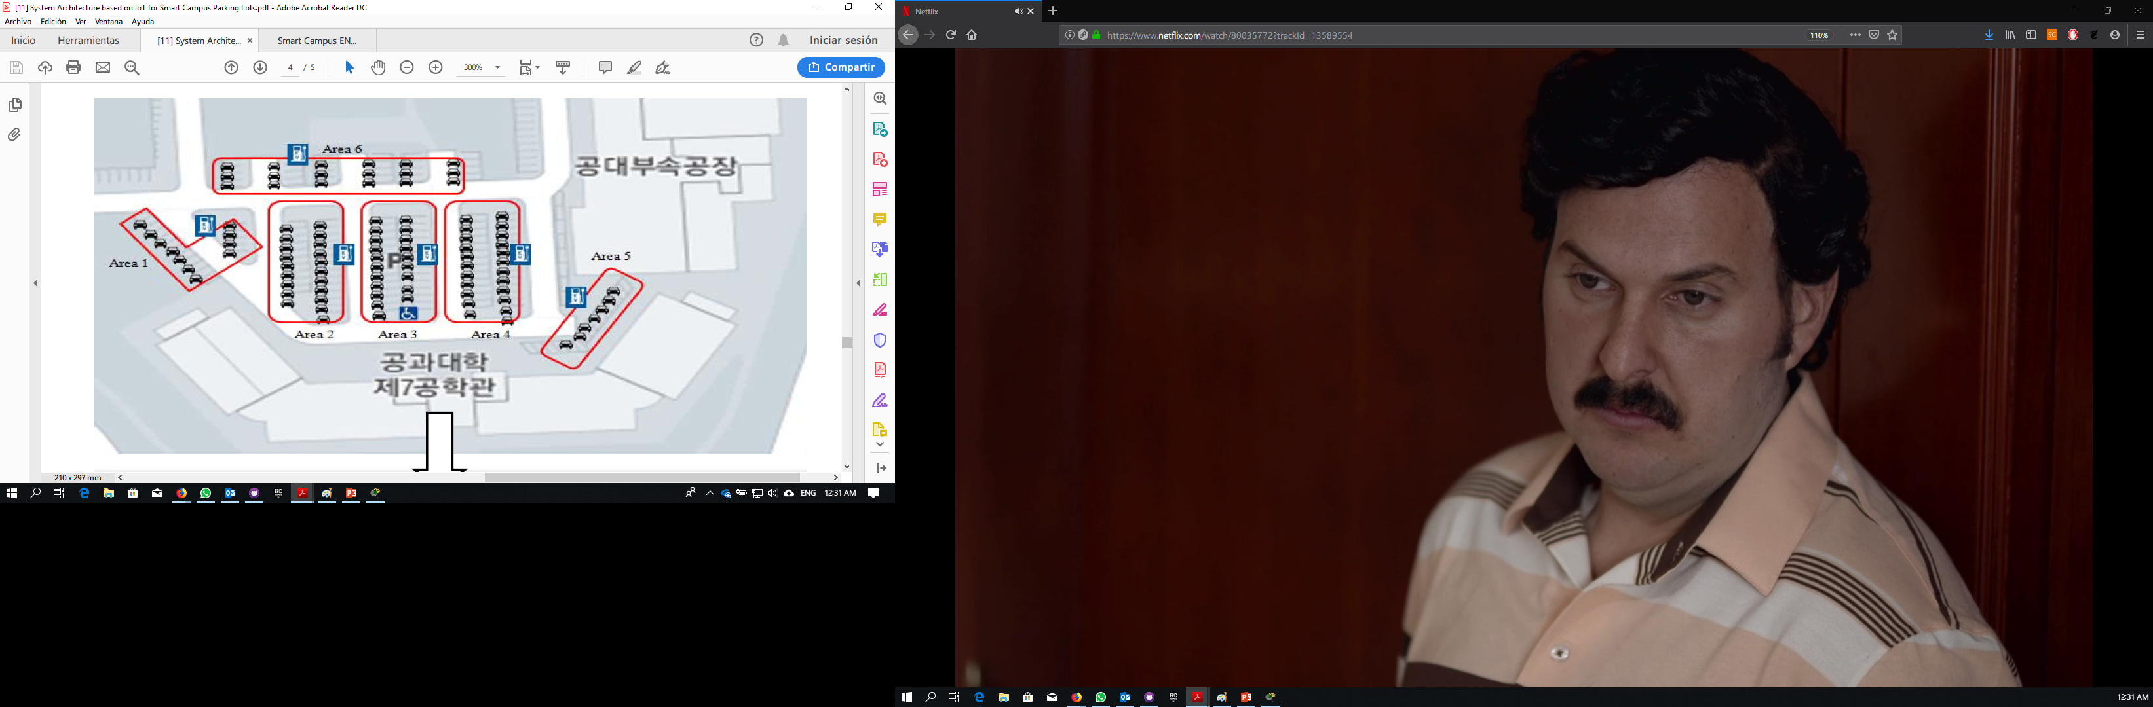

**Figure 1. Diagram EPCON**

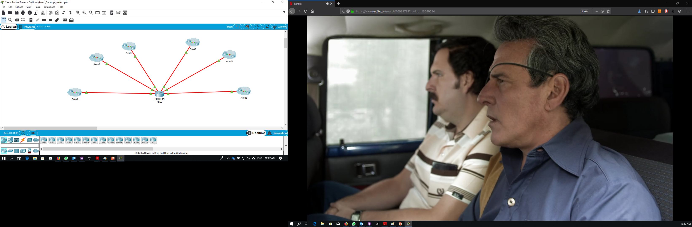In figure 1 we find the distribution of the loading stations that are part of our grid, we have 6 feeders each subdivided in a specific area, in figure 2b we see the distribution made in the CISCO PACKET TRACER software with the real distances and the equipment that we use

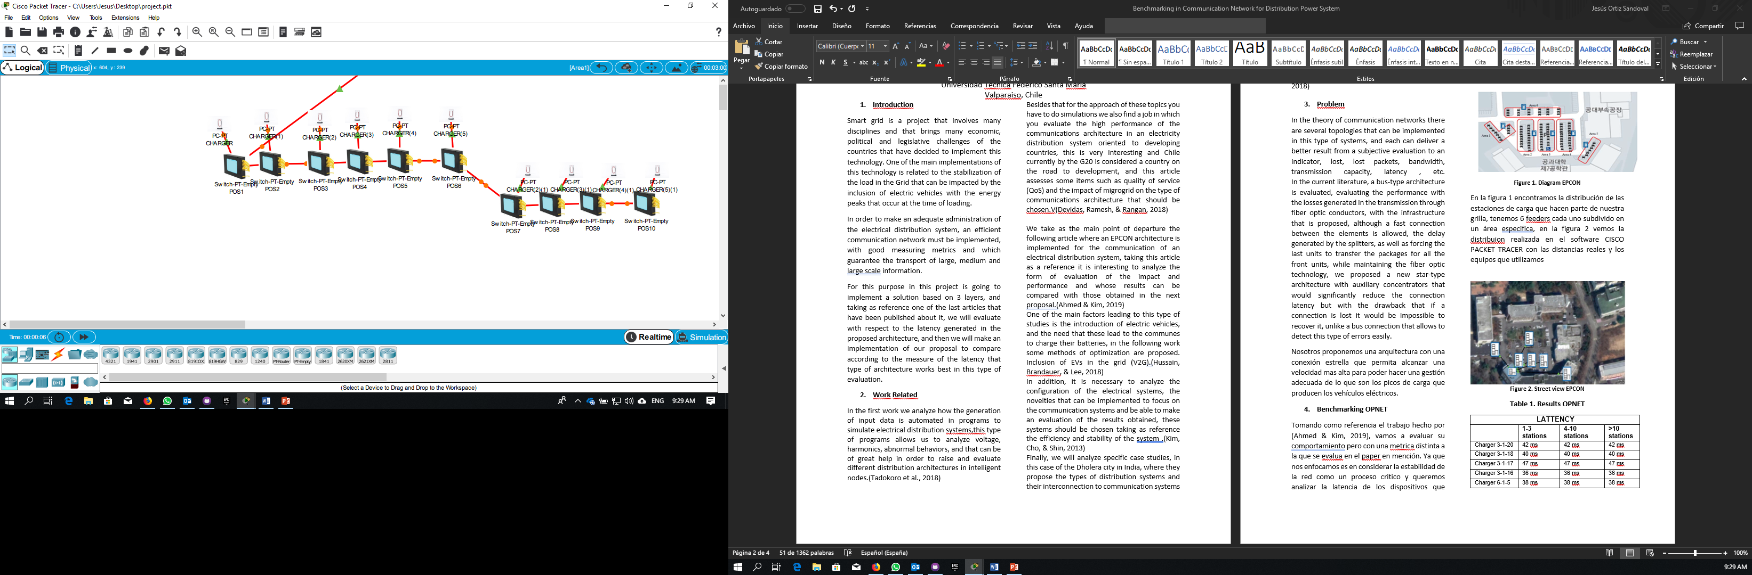

**Figura 2a. Logical network**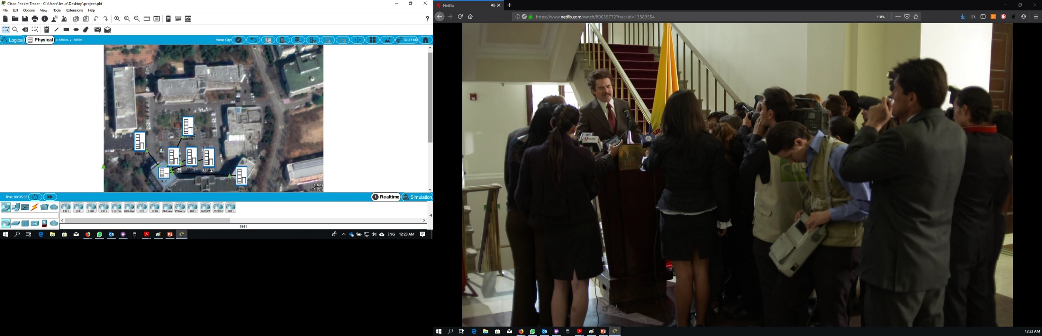

**Figure 2b. Street view EPCON**

**Table 1. Results OPNET**

|  |  |  |  |
| --- | --- | --- | --- |
| **LATTENCY** | | | |
|  | **1-3 stations** | **4-10 stations** | **>10 stations** |
| Charger 3-1-20 | 42 ms | 42 ms | 42 ms |
| Charger 3-1-18 | 40 ms | 40 ms | 40 ms |
| Charger 3-1-17 | 47 ms | 47 ms | 47 ms |
| Charger 3-1-16 | 36 ms | 36 ms | 36 ms |
| Charger 6-1-5 | 38 ms | 38 ms | 38 ms |
| Charger 5-1 | 22 ms | 22 ms | 22 ms |
| Charger 6-1-15 | 36ms | 36ms | 36ms |
| Charger 4-1-7 | 34 ms | 34 ms | 34 ms |

1. **Proposed architecture for the USM Campus**

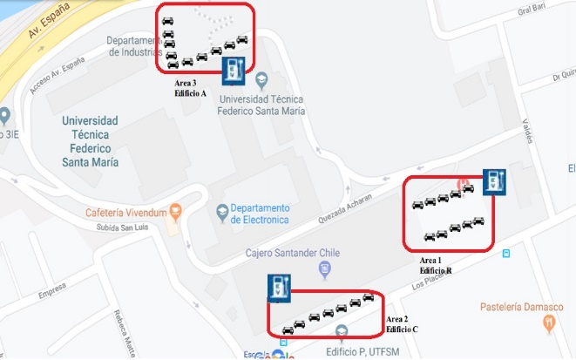

**Figure 3. Diagram USM Campus Network**

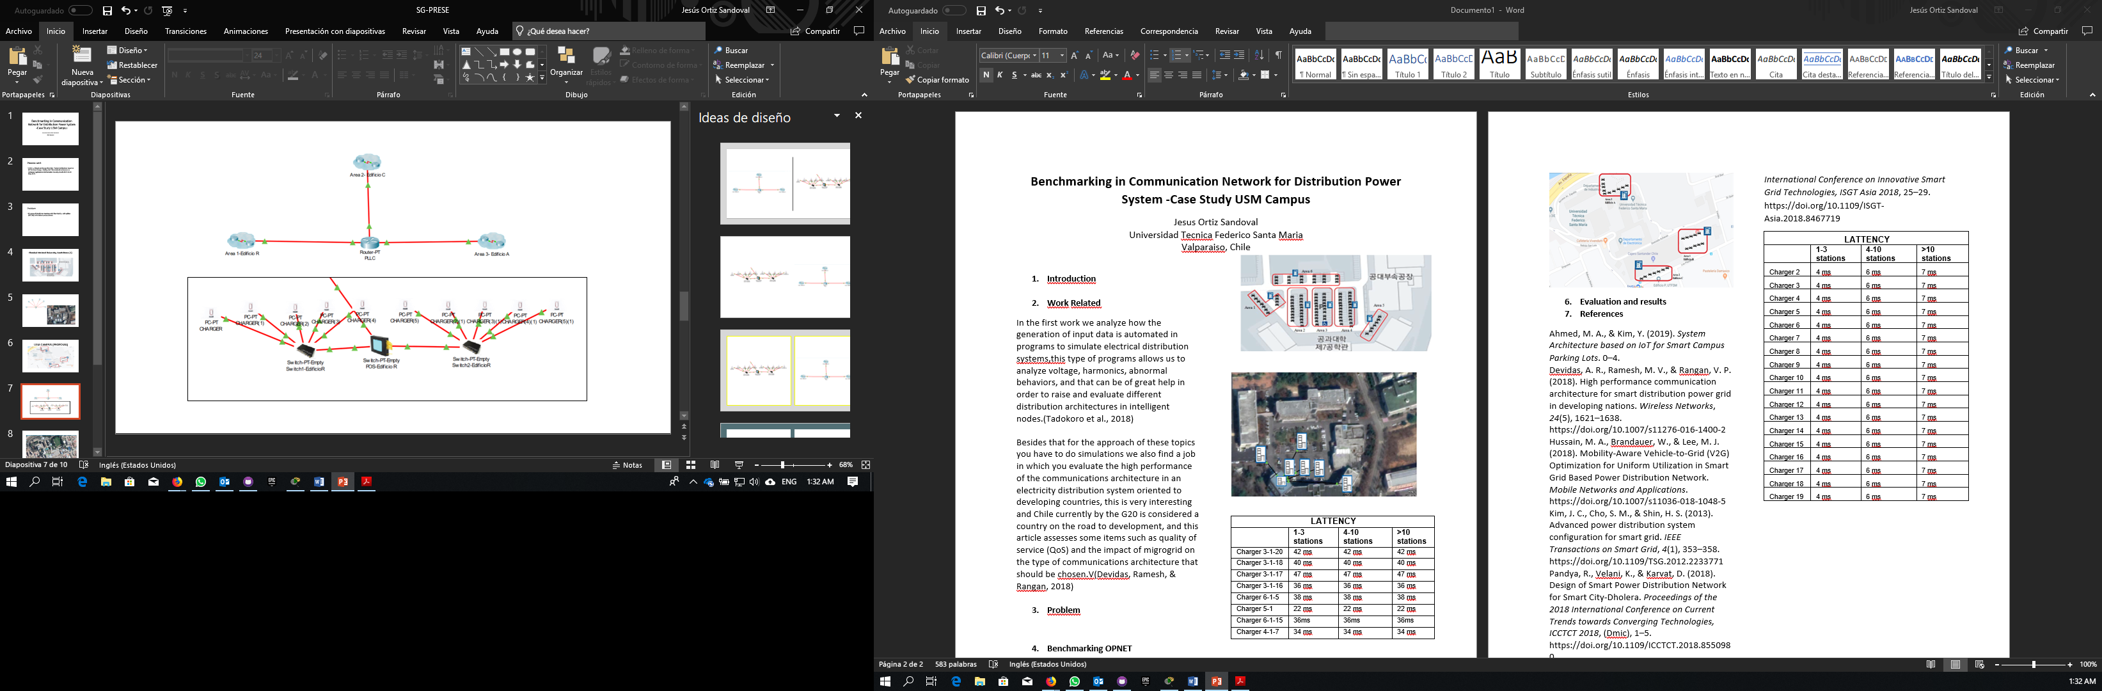

**Figure 4. CISCO Packet tracer network**

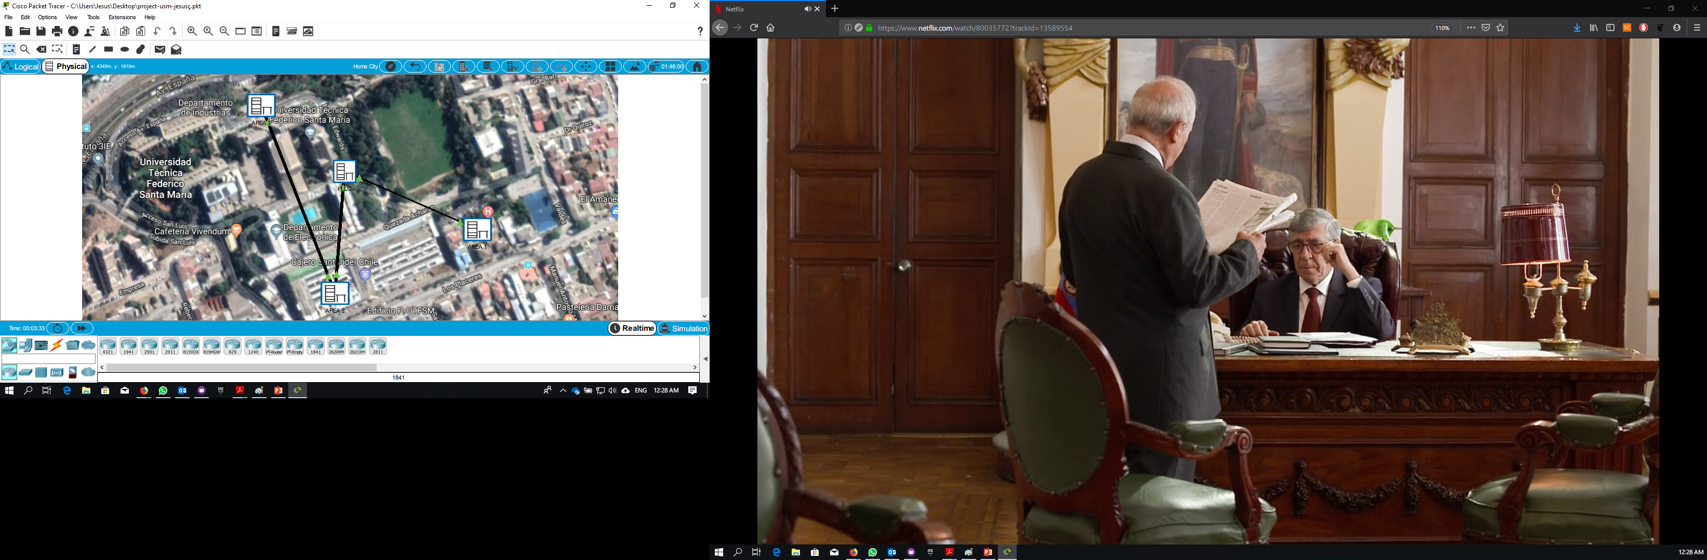

**Figure 5. Street View Network USM Campus**

1. **Evaluation and results**

**Table 2. Results USM Campus**

|  |  |  |  |
| --- | --- | --- | --- |
| **LATTENCY** | | | |
|  | **1-3 stations** | **4-10 stations** | **>10 stations** |
| Charger 2 | 4 ms | 6 ms | 7 ms |
| Charger 3 | 4 ms | 6 ms | 7 ms |
| Charger 4 | 4 ms | 6 ms | 7 ms |
| Charger 5 | 4 ms | 6 ms | 7 ms |
| Charger 6 | 4 ms | 6 ms | 7 ms |
| Charger 7 | 4 ms | 6 ms | 7 ms |
| Charger 8 | 4 ms | 6 ms | 7 ms |
| Charger 9 | 4 ms | 6 ms | 7 ms |
| Charger 10 | 4 ms | 6 ms | 7 ms |
| Charger 11 | 4 ms | 6 ms | 7 ms |
| Charger 12 | 4 ms | 6 ms | 7 ms |
| Charger 13 | 4 ms | 6 ms | 7 ms |
| Charger 14 | 4 ms | 6 ms | 7 ms |
| Charger 15 | 4 ms | 6 ms | 7 ms |
| Charger 16 | 4 ms | 6 ms | 7 ms |
| Charger 17 | 4 ms | 6 ms | 7 ms |
| Charger 18 | 4 ms | 6 ms | 7 ms |
| Charger 19 | 4 ms | 6 ms | 7 ms |

1. **References**

Ahmed, M. A., & Kim, Y. (2019). *System Architecture based on IoT for Smart Campus Parking Lots*. 0–4.

Devidas, A. R., Ramesh, M. V., & Rangan, V. P. (2018). High performance communication architecture for smart distribution power grid in developing nations. *Wireless Networks*, *24*(5), 1621–1638. https://doi.org/10.1007/s11276-016-1400-2

Hussain, M. A., Brandauer, W., & Lee, M. J. (2018). Mobility-Aware Vehicle-to-Grid (V2G) Optimization for Uniform Utilization in Smart Grid Based Power Distribution Network. *Mobile Networks and Applications*. https://doi.org/10.1007/s11036-018-1048-5

Kim, J. C., Cho, S. M., & Shin, H. S. (2013). Advanced power distribution system configuration for smart grid. *IEEE Transactions on Smart Grid*, *4*(1), 353–358. https://doi.org/10.1109/TSG.2012.2233771

Pandya, R., Velani, K., & Karvat, D. (2018). Design of Smart Power Distribution Network for Smart City-Dholera. *Proceedings of the 2018 International Conference on Current Trends towards Converging Technologies, ICCTCT 2018*, (Dmic), 1–5. https://doi.org/10.1109/ICCTCT.2018.8550980

Tadokoro, T., Noda, T., Ishimoto, K., Okada, N., Uemura, S., & Shumuta, Y. (2018). Automatic Generation of Input Data for Distribution System Simulation Programs. *International Conference on Innovative Smart Grid Technologies, ISGT Asia 2018*, 25–29. <https://doi.org/10.1109/ISGT-Asia.2018.8467719>

Guo Jing-tian, Zhai Chun-heng, Liu Xing-hua, Zhu Guo-fang, Hou Mei-yi, Zou Gui-bin, … Zhang Ning. (2014). *Application of IEEE1588 in Time Synchronizing System of Smart Distribution Grid*. 12.65-12.65. https://doi.org/10.1049/cp.2014.0138

Huang, H., & Zhang, H. (2011). Application and Analysis of Long-Distance EPON in Transmission Lines Monitoring System. *Advanced Materials Research*, *317*–*319*, 1583–1589. https://doi.org/10.4028/www.scientific.net/amr.317-319.1583

Sun, Z., Guo, Q., Ma, Y., & Sun, F. (2010). *Communication System for Distribution Automation Using EPON*. 1–4. https://doi.org/10.1109/cise.2009.5363237